Industries - Healthcare

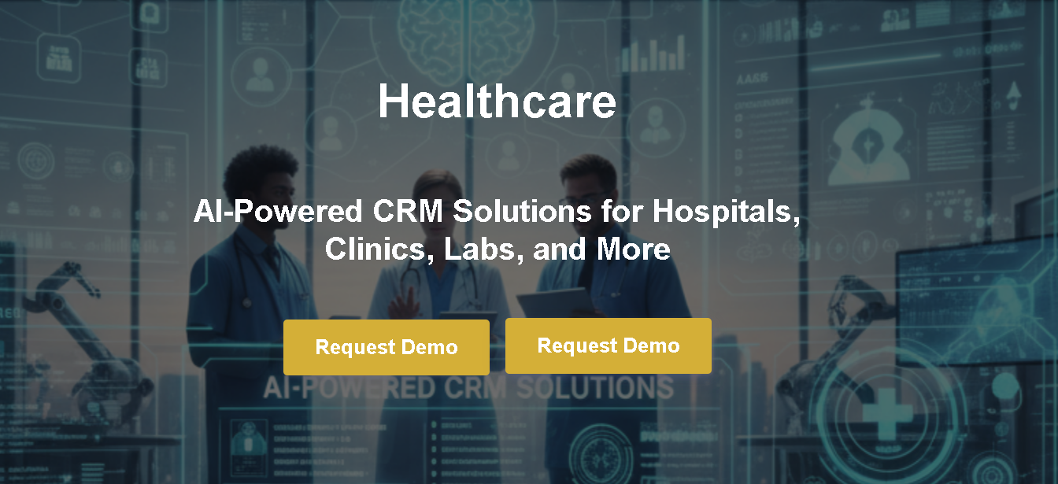

Your All-in-One AI-Powered CRM for Healthcare Professionals

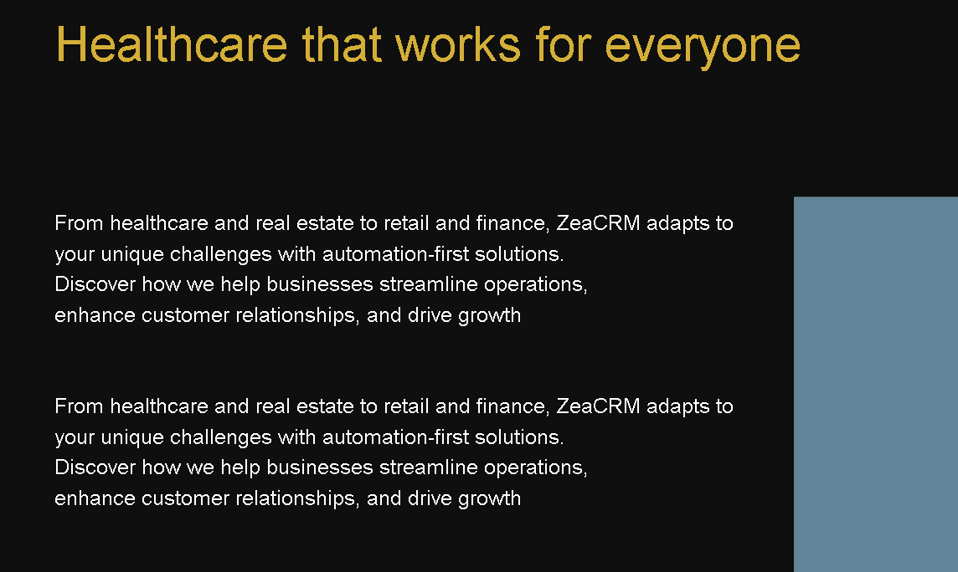

Smarter Healthcare Relationship Management
In healthcare, every interaction counts. Right from the first appointment booking to long-term patient engagement. ZeaCRM helps hospitals, clinics, labs, and wellness centeras manage patient relationships with precision, empathy, and speed.

Built with AI automation, ZeaCRM simplifies operations that often overwhelm healthcare teams. From scheduling and reminders to patient communication and record tracking, every process becomes smoother, faster, and more reliable. This is so your staff can focus on care, not coordination.

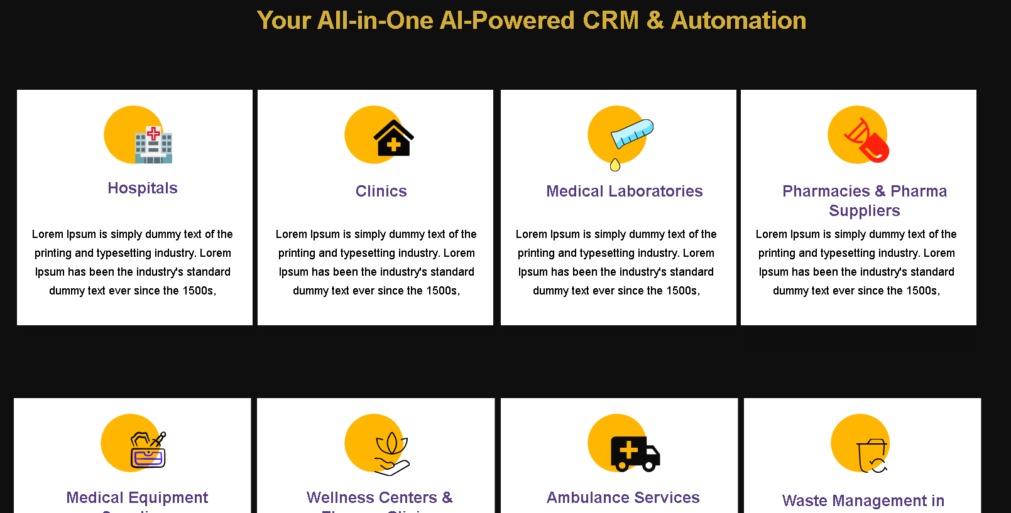

Who We Help
ZeaCRM is designed to support every corner of the healthcare ecosystem:

- Hospitals – Coordinate departments, manage patient journeys, and streamline follow-ups.
- Clinics – Automate appointment reminders, patient histories, and communication.
- Diagnostic Labs – Send test results automatically and manage client feedback.
- Nursing Homes – Monitor residents’ care plans and automate family updates.
- Pharmacies – Track prescriptions, refill reminders, and customer interactions.
- Medical Equipment Suppliers – Manage leads, inventory updates, and client orders.
- Health Insurance Providers – Simplify claims communication and client tracking.
- Wellness & Therapy Centers – Personalize client plans and maintain session logs.
- Dental Practices – Schedule visits, manage follow-ups, and automate recalls.
- Home Care Agencies – Assign caregivers, manage schedules, and maintain case histories.
- Telemedicine Providers – Integrate calls, chats, and consultations in one view.

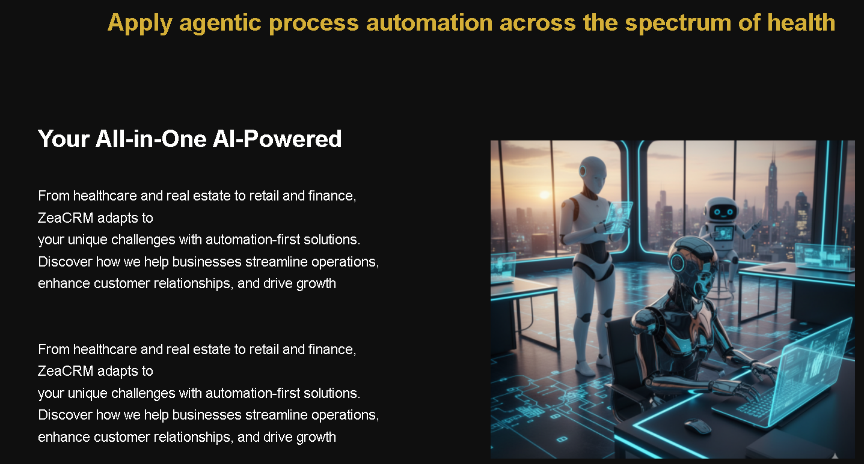

All-in-One Platform for Modern Healthcare Teams
ZeaCRM connects every team, department, and workflow under one powerful AI-driven system. It ensures seamless collaboration across medical, administrative, and support units. All this so that nothing slips through the cracks.

From automated scheduling and smart notifications to AI insights that predict patient needs, ZeaCRM gives healthcare providers the clarity and control they need to deliver exceptional service every day. The result? Higher efficiency, happier patients, and smoother operations.

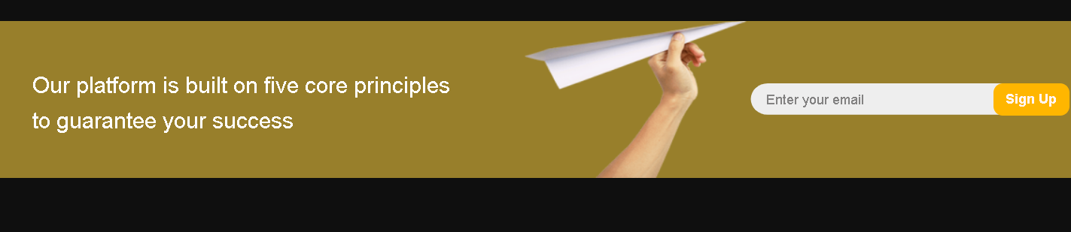

Let’s Simplify Your Healthcare Management
Experience how ZeaCRM can change your healthcare organization with intelligent automation and insight-driven operations.

Real Estate

AI-Powered CRM Solutions for Builders, Agents, and Property Consultants

Smarter Sales and Relationship Management for Real Estate
In real estate, timing and relationships drive every deal. ZeaCRM helps real estate professionals manage clients, properties, and transactions with complete visibility and automation. You could be handling multiple listings, tracking buyer interest, or nurturing long-term investor relationships. Everything happens seamlessly from one intelligent platform.

Built with AI-driven insights, ZeaCRM helps you predict which leads are most likely to convert, automate follow-ups, and personalize communication. From initial inquiry to closing day, you’ll always know exactly where every deal stands, saving time and maximizing every opportunity.

Who We Help
ZeaCRM simplifies operations for every segment of the real estate ecosystem:

- Real Estate Agencies – Manage listings, track leads, and automate property updates.
- Property Developers – Monitor projects, coordinate teams, and manage investor relations.
- Independent Agents – Keep track of every client interaction, inquiry, and follow-up in one place.
- Builders – Oversee multiple projects and streamline customer communication.
- Property Consultants – Organize buyer preferences and match them to listings instantly.
- Brokerage Firms – Automate client onboarding and documentation.
- Rental Managers – Schedule viewings, track maintenance requests, and manage tenants.
- Commercial Realtors – Handle B2B deals, lease renewals, and portfolio management.
- Interior Designers & Home Stylists – Collaborate with clients and manage project timelines easily.
- Real Estate Investors – Track portfolios, manage partners, and analyze ROI trends.
- Housing Societies – Manage resident databases, payments, and service requests.

All-in-One Platform for Real Estate Success
ZeaCRM connects your sales, marketing, and customer support teams on a single, powerful dashboard. Every lead, listing, and communication is tracked automatically, giving you full transparency into your pipeline.

With AI-powered recommendations, real-time notifications, and integrated tools like WhatsApp, Gmail, and property portals, ZeaCRM ensures you never miss an opportunity to close faster and build stronger client relationships. From inquiry to handover. Everything stays organized, automated, and easy to manage.

Let’s Simplify Your Real Estate Management
Experience how ZeaCRM can change your real estate business with intelligent automation and complete control over your sales cycle.

Retail & E-Commerce

AI-Powered CRM Solutions for Stores, Brands, and Online Businesses

Smarter Customer Engagement for Modern Retail
Customer experience defines brand loyalty. ZeaCRM helps retail and e-commerce businesses deliver seamless, personalized engagement. Right from discovery to delivery. Whether you’re managing a physical store or a global online brand, ZeaCRM brings all your customer interactions, marketing campaigns, and order insights under one intelligent system.

With built-in automation and AI recommendations, you can manage promotions, track buying behavior, and follow up with customers effortlessly. ZeaCRM ensures that every message, discount, or update reaches the right person at the right time. We are turning browsers into loyal buyers.

Who We Help
ZeaCRM empowers every part of the retail and e-commerce ecosystem:

- Online Stores – Automate email campaigns, order updates, and customer feedback.
- Retail Chains – Manage multiple outlets and track customer engagement across locations.
- Fashion Brands – Personalize product recommendations and loyalty offers.
- Grocery & FMCG Stores – Schedule reorders and notify customers about new arrivals.
- Electronics Retailers – Manage warranties, repairs, and customer service tickets.
- Luxury Boutiques – Build exclusive loyalty programs and VIP communication flows.
- Beauty & Wellness Brands – Automate appointment reminders and after-purchase follow-ups.
- Home Décor Stores – Track high-value leads and manage interior project coordination.
- E-Commerce Marketplaces – Integrate customer chats, support tickets, and feedback channels.
- Subscription-Based Businesses – Manage recurring orders, renewals, and engagement cycles.
- Franchise Networks – Maintain centralized control over customer data and marketing.

All-in-One Platform for Retail Success
ZeaCRM brings your marketing, sales, and support teams together on a single platform that scales with your business. AI-driven segmentation and predictive analytics help you understand buying patterns, personalize campaigns, and boost repeat purchases.

Integrate ZeaCRM with your existing e-commerce tools like Shopify, WooCommerce, or payment gateways, and see every customer interaction in one view. From cart recovery to post-purchase engagement, ZeaCRM keeps your brand connected, responsive, and ready to grow.

Let’s Simplify Your Retail Growth
Experience how ZeaCRM can power your retail and e-commerce business with automation, insights, and effortless communication.

Professional Services

AI-Powered CRM Solutions for Consultants, Agencies, and Service Firms

Smarter Client Management for Service Professionals
When it comes to professional services, your relationships are your most valuable asset. ZeaCRM helps consultants, agencies, and service-based firms build stronger client relationships, manage projects efficiently, and automate repetitive communication - all in one intuitive platform.

With AI-driven insights, you can track leads, forecast revenue, and manage ongoing contracts seamlessly. Whether you’re a legal advisor, digital agency, financial consultant, or training provider, ZeaCRM keeps your client data organized, communication consistent, and delivery on track.

Who We Help
ZeaCRM adapts perfectly to every segment of the professional services industry:

- Consulting Firms – Manage clients, proposals, and follow-ups efficiently.
- Marketing & Advertising Agencies – Automate campaigns, client reporting, and approvals.
- Legal Services – Track case progress, client communication, and document workflows.
- Financial Advisors – Manage client portfolios, renewals, and compliance reminders.
- IT & Software Companies – Handle client projects, tickets, and onboarding with ease.
- Architects & Interior Designers – Manage leads, design consultations, and project stages.
- Accounting Firms – Automate billing updates, reminders, and client coordination.
- HR & Recruitment Agencies – Track candidates, placements, and client requirements.
- Training & Coaching Providers – Schedule sessions, manage enrollments, and track outcomes.
- Event Management Companies – Oversee vendors, client briefs, and post-event follow-ups.
- Public Relations Firms – Maintain media lists, client deliverables, and performance reports.

All-in-One Platform for Client-Focused Success
ZeaCRM helps professional service providers bring structure to complex workflows and client communication. From proposal to project completion, every interaction is tracked, analyzed, and optimized through AI-powered automation.

Collaborate with your team, automate reminders, and access all client information in one secure dashboard. ZeaCRM gives you the clarity and control to deliver consistent, high-quality service. All while spending less time on administration and more time on impact.

Let’s Simplify Your Client Management
Discover how ZeaCRM can transform your service business with automation, intelligence, and effortless organization.

Education & Training

AI-Powered CRM Solutions for Schools, Colleges, Institutes, and EdTech Platforms

Smarter Relationship Management for Learning Institutions
Education is built on meaningful connections between institutions, students, and faculty. ZeaCRM helps educational organizations and training providers streamline admissions, automate communication, and track engagement through one intelligent platform.

From inquiry to enrollment, ZeaCRM gives you complete visibility into every student interaction. Whether it’s managing thousands of leads for a university or handling class schedules for a training institute, ZeaCRM ensures no opportunity is missed, and every learner receives the attention they deserve.

Who We Help
ZeaCRM brings automation and clarity to all segments of the education and training sector:

- Schools – Manage admissions, parent communication, and student progress efficiently.
- Colleges & Universities – Automate application follow-ups, enrollment reminders, and alumni engagement.
- Training Institutes – Handle batch schedules, student records, and course renewals with ease.
- EdTech Platforms – Track user engagement, demo sessions, and course conversions.
- Coaching Centers – Automate lead capture, inquiry follow-ups, and feedback collection.
- Language Academies – Schedule sessions, manage tutors, and send personalized updates.
- Online Learning Platforms – Segment learners, track course completion, and manage subscriptions.
- Vocational Training Centers – Record attendance, manage certifications, and streamline communication.
- Corporate Training Providers – Track client organizations, training schedules, and post-program reports.
- Skill Development Programs – Automate outreach and manage participants across multiple batches.
- Educational Consultants – Manage student applications, partnerships, and visa documentation.

All-in-One Platform for Smarter Education Management
ZeaCRM integrates all student, staff, and partner interactions into a unified platform. We are reducing manual effort and improving engagement. AI-driven automation ensures that every inquiry, application, and update is handled promptly and professionally.

With built-in analytics, institutions can monitor admissions performance, identify trends, and personalize communication. ZeaCRM helps you spend less time managing data and more time shaping learning outcomes.

Let’s Simplify Your Education Management
See how ZeaCRM can transform your educational or training organization with automation, analytics, and effortless coordination.

Finance & Insurance

AI-Powered CRM Solutions for Banks, Advisors, and Insurance Providers

Smarter Relationship Management for Financial Growth
In finance and insurance, trust and timing drive every relationship. ZeaCRM helps financial institutions, insurance providers, and advisors manage leads, automate communication, and deliver personalized service with ease.

From client onboarding to policy renewals and loan tracking, ZeaCRM gives you a complete 360° view of every customer interaction. With AI-powered insights, it helps you prioritize high-value clients, follow up automatically, and make smarter business decisions faster and more securely.

Who We Help
ZeaCRM is built to empower every segment of the finance and insurance ecosystem:

- Banks & Financial Institutions – Manage clients, automate reminders, and track loan applications.
- Insurance Companies – Streamline policy management, claims tracking, and customer communication.
- Wealth Management Firms – Monitor client portfolios and send timely investment updates.
- Financial Advisors – Track leads, manage renewals, and maintain compliance effortlessly.
- Brokerage Firms – Manage investor relationships and automate client reporting.
- Credit Unions – Simplify account management and improve member engagement.
- Mortgage Consultants – Track applications, approvals, and follow-ups with ease.
- Insurance Agents – Automate renewals, client outreach, and policy tracking.
- FinTech Startups – Integrate APIs, automate leads, and gain actionable customer insights.
- Microfinance Companies – Manage clients, disbursements, and repayment cycles efficiently.
- Investment Firms – Segment investors and track opportunities across portfolios.

All-in-One Platform for Smarter Financial Operations
ZeaCRM centralizes every lead, transaction, and client communication into one secure and compliant dashboard. It integrates seamlessly with your accounting, payment, and communication tools to ensure your business runs smoothly and transparently.

AI-driven automation ensures that renewals, due dates, and customer interactions happen at the right time. All this without the need for any manual follow-ups. From financial analysis to personalized policy management, ZeaCRM keeps your business efficient, compliant, and client-ready at all times.

Let’s Simplify Your Financial Management
Find out how ZeaCRM can transform your finance or insurance operations with automation, analytics, and secure customer relationship management.

Automotive & Manufacturing

AI-Powered CRM Solutions for Dealers, Distributors, and Manufacturers

Smarter Operations and Customer Management for Industrial Growth
In the automotive and manufacturing sectors, efficiency is everything. It matters a lot right from lead generation to after-sales service. With this in mind, ZeaCRM helps manufacturers, suppliers, and dealerships automate processes, track performance, and maintain strong relationships across their entire value chain.

Whether you’re managing B2B contracts, dealer networks, or end-customer engagement, ZeaCRM gives you full visibility and control. With AI automation, you can streamline sales cycles, improve production coordination, and build lasting business relationships that drive growth and loyalty.

Who We Help
ZeaCRM is built to serve every level of the automotive and manufacturing ecosystem:

- Automobile Dealerships – Manage leads, test drives, and post-sale service reminders.
- Car Service Centers – Track maintenance schedules, customer history, and service follow-ups.
- Auto Parts Distributors – Automate order management and inventory tracking.
- Vehicle Leasing Companies – Manage renewals, payment tracking, and customer updates.
- OEM Manufacturers – Coordinate supplier relationships and production schedules.
- Component Suppliers – Track B2B clients, deliveries, and contracts efficiently.
- Industrial Equipment Manufacturers – Manage client orders, project timelines, and after-sales support.
- Machinery Dealers – Handle quotations, demos, and service contracts with automation.
- Logistics & Fleet Operators – Track vehicle usage, contracts, and maintenance records.
- EV Companies – Manage dealership networks, charging partnerships, and customer data.
- Spare Parts Retailers – Organize inventory, billing, and repeat customer communication.

All-in-One Platform for Automotive & Industrial Excellence
ZeaCRM unites your sales, operations, and service teams in one intelligent platform. It eliminates silos by integrating customer data, orders, and performance metrics in real time. This allows your team to make faster decisions and stronger collaboration.

With AI-powered analytics, you can forecast demand, monitor performance trends, and automate customer outreach. From factory floors to showrooms, ZeaCRM helps you stay efficient, connected, and future-ready.

Let’s Simplify Your Manufacturing & Automotive Management
Experience how ZeaCRM can streamline your industrial or automotive operations with automation, analytics, and effortless coordination.

Other Industries

AI-Powered CRM Solutions for Every Business Sector

Smarter Relationship Management Across Every Industry
Every business, no matter the sector, depends on strong relationships and efficient communication. ZeaCRM brings automation, intelligence, and organization to industries that thrive on consistency, coordination, and customer satisfaction.

From logistics to travel, entertainment to non-profits, ZeaCRM adapts to your unique workflows. The platform helps you automate repetitive tasks, track every interaction, and turn data into actionable insights. This is ensuring smarter decisions and faster growth, no matter what business you’re in.

Who We Help
ZeaCRM is flexible and scalable, supporting a wide range of industries beyond traditional sectors:

- Hospitality & Travel – Manage guest bookings, loyalty programs, and personalized experiences.
- Logistics & Supply Chain – Track shipments, automate updates, and manage vendor communication.
- Non-Profit Organizations – Handle donor management, campaigns, and volunteer coordination.
- Media & Entertainment – Manage talent, projects, sponsorships, and audience engagement.
- Event Management Companies – Track clients, vendors, and event workflows easily.
- Energy & Utilities – Manage service requests, billing, and customer support efficiently.
- Construction & Real Estate Services – Oversee leads, contracts, and project milestones.
- Agriculture & Agri-Tech – Track distributors, farmers, and seasonal demand cycles.
- Public Sector & Government Projects – Manage citizen services, feedback, and communication records.
- Telecommunication Providers – Automate service updates, renewal alerts, and customer outreach.
- Recruitment & Staffing Firms – Manage job openings, candidate pipelines, and employer relationships.

All-in-One Platform for Every Business Need
ZeaCRM’s flexible architecture adapts to your business model whether you specialize in B2B, B2C, or hybrid. With powerful AI automation, real-time dashboards, and seamless integrations, it helps teams stay connected and productive across functions.

You can customize workflows, automate follow-ups, and gain insights tailored to your industry without extra complexity. ZeaCRM grows with you, supporting your expansion into new markets and helping your team stay focused on what matters most: results.

Let’s Simplify Your Business Management
See how ZeaCRM can adapt to your industry and empower your team with smarter automation and insights.

Pricing

One Powerful Platform. Simple Pricing
No hidden costs, no complex tiers. Just transparent plans that give you everything you need to grow, automate, and connect with your customers.

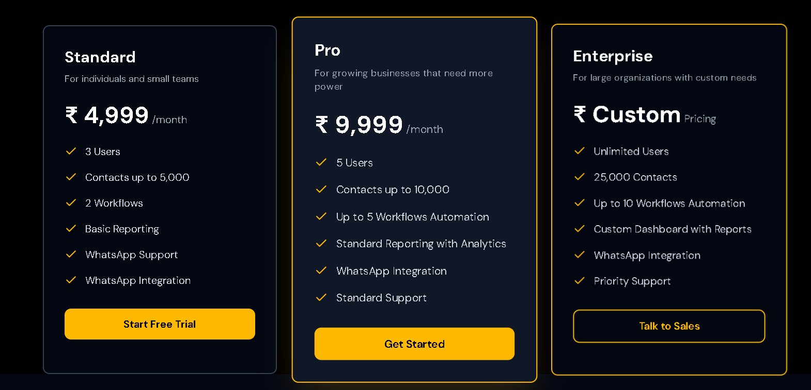

What Our Customers Say

CRM & Pipeline Management
"ZeaCRM turned my scattered client data into a clear sales map. I can finally see every deal at a glance."

Unlimited Sales Funnels
"I used to juggle three tools for funnels. Now, ZeaCRM does it all faster and cleaner."

Website Builder
"Built my coaching website in one afternoon. It’s fast, flexible, and looks professional."

Surveys & Forms
"Patient feedback used to take weeks. Now I collect and analyze it within hours."

Email Marketing
"Our open rates jumped 40% after switching to ZeaCRM. The automation just works better here."

2-Way SMS Messaging
"Instant replies mean happier customers and more bookings. We were able to gain better conversions and ROI with the 2-way SMS system."

Booking & Appointments
"My clients love the ease of scheduling. I love the automatic reminders so I can focus on other tasks without worrying about forgetting something."

Workflow Automations
"What used to take my team three hours now happens while we sleep. ZeaCRM is the best decision our team has taken this year."

Courses/Products
"Managing my online training business became effortless. Everything syncs beautifully."

Frequently Asked Questions

Can I try ZeaCRM for free before choosing a plan?
Yes, you can explore ZeaCRM with a free trial with no credit card required. Test the features, automation tools, and dashboard to see how it fits your workflow before making a commitment.

Can I upgrade or downgrade anytime?
Yes, ZeaCRM is built with flexibility in mind. You can upgrade, downgrade, or cancel anytime directly from your dashboard without losing your data or settings.

Is my data safe?
Your security is our top priority. ZeaCRM uses advanced encryption, secure cloud hosting, and multi-layer authentication to protect your business and customer data at every step. We comply with global privacy standards to ensure complete peace of mind.

Does ZeaCRM offer support or onboarding help?
Yes, our onboarding team helps you get started, migrate data, and set up automations at no extra cost. You can reach out to our team for help 24/7 before, during, and after your onboarding process.

Can multiple users access the same account?
Yes, ZeaCRM supports multiple team members. Your entire team can collaborate across sales, marketing, and operations seamlessly at the same time.

Playbooks

Explore ZeaCRM Playbooks. This is your hub for expert blogs, step-by-step guides, and actionable resources. Check this page for the latest updates you need to master sales, automation, and customer success.

